**Project Proposal for NeV Application**

**Problem Statement:**

The organic food industry faces significant challenges related to trust and transparency. Consumers often question the authenticity of food labelled as organic, while farmers and vendors struggle to validate their products and meet regulatory standards. Key problems include:

* Lack of trust in the organic labelling process.
* Inadequate systems for verifying and tracking organic produce through the supply chain.
* Limited collaboration between farmers, regulatory bodies, vendors, and consumers.

**Objective**:  
To develop a transparent and trustworthy platform that connects farmers, vendors, regulatory bodies, and consumers in a seamless ecosystem, ensuring the authenticity of organic food.

**Proposed Solution:**

We propose NeV Wellness, a comprehensive platform to address these challenges by:

1. **Building Trust:** Providing a transparent supply chain that verifies organic produce at each stage.
2. **Integrating Stakeholders:** Connecting farmers, regulatory bodies, vendors, and consumers.
3. **Automating Workflows:** Streamlining requests for shipping, approval, and client orders.
4. **Enhancing Consumer Access:** Empowering consumers to consult dietitians and access personalized diet plans.

**High-Level Component Diagram:**

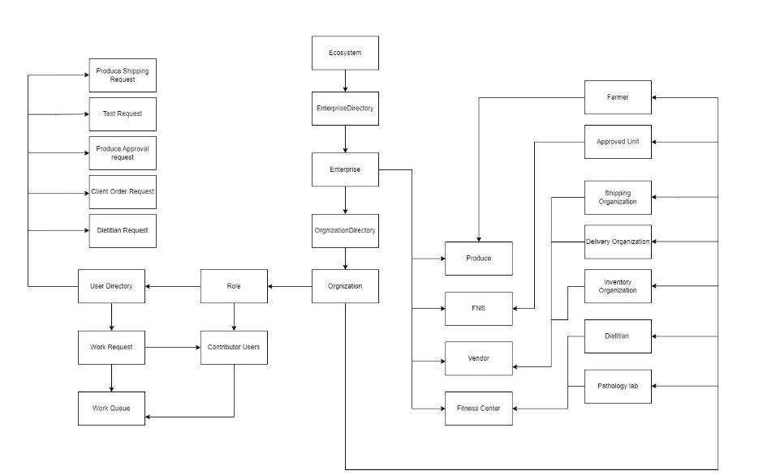

• Ecosystem: The central framework connecting enterprises, users, roles, and workflows.

• Enterprise **Directory**: Manages and organizes all enterprises in the system.

• Enterprise: Represents top-level business units like Produce, FNS, Vendor, and Fitness Center.

• Organization **Directory**: Connects enterprises to specialized organizations under them.

• Produce **Enterprise**: Manages farming, produce approval, and shipping operations.

• FNS **Enterprise**: Focuses on food and nutrition services, including dietitians and pathology labs.

• Vendor **Enterprise**: Handles inventory and delivery management for organic produce.

• Fitness **Center Enterprise**: Provides wellness services through dietitians and gyms.

• Role **Management**: Assigns roles to users and defines their responsibilities.

• User **Directory**: Maintains a list of all users and their associated roles.

• Work **Queue**: Automates task allocation and tracks requests like shipping, testing, and approvals.

• Requests: Includes workflows such as Produce Shipping, Client Orders, and Dietitian Requests.

**Ecosystem Hierarchy:**

1. **Ecosystem:**
   * The central hub managing the entire platform, including enterprises, users, and workflows.
   * Directly connected to:
     + **Enterprise Directory**: Stores and organizes all enterprises within the system.
     + **User Directory**: Manages users' roles and accounts.
2. **Enterprise and Organization Management:**
   * **Enterprise**: Represents high-level business units, such as:
     + **Produce**: Handles farming, produce approval, and shipping.
     + **FNS (Food and Nutrition Services)**: Focuses on diet planning and nutritional analysis.
     + **Vendor**: Manages inventory and order delivery.
     + **Fitness Center**: Integrates dietitians and health services.
   * **OrganizationDirectory**: Connects enterprises to specific organizations under them:
     + **Produce Enterprise**:
       - Farmer Organization
       - Approved Unit
       - Shipping Organization
     + **FNS and Fitness Center**:
       - Delivery Organization
       - Inventory Organization
       - Dietitian Organization
       - Pathology Lab
3. **Workflows and Requests:**
   * **Work Requests**:
     + Manage communication and task delegation between users and organizations.
     + Types of requests include:
       - **Produce Shipping Request**
       - **Test Request**
       - **Produce Approval Request**
       - **Client Order Request**
       - **Dietitian Request**
   * **Work Queue**:
     + Automates task allocation and tracks the status of requests across enterprises.
4. **Role Management:**
   * **Roles**:
     + Defines permissions and responsibilities for system users.
     + Examples:
       - Farmer
       - Dietitian
       - Vendor Enterprise Admin
       - Pathologist
       - Agriculture Enterprise Admin
       - Client
       - Delivery Person
       - FNS Admin
       - FNS Enterprise Admin
       - Fitness Center Enterprise Admin
       - Inventory Manager
       - Nutrition Analyst
       - Quality Approver
       - Shipping Manager
       - System Admin
   * **Contributor Users**:
     + The individuals or entities assigned specific roles within the system.
5. **Interactions Between Components:**
   * **Produce Enterprise**:
     + Farmers submit requests for shipping and produce approval.
     + Approved Units validate the quality and authenticity of organic food.
   * **FNS Enterprise**:
     + Dietitians create and recommend diet plans for consumers.
     + Pathology Labs verify test results to tailor diet recommendations.
   * **Vendor Enterprise**:
     + Vendors handle inventory and delivery, connecting directly with consumers.
   * **Fitness Center Enterprise**:
     + Dietitians and gyms collaborate to promote overall wellness.

**Use Cases:**

1. **For Consumers**:

* Consult dietitians for health plans.
* Access diets based on health test results.
* Purchase verified organic produce.

1. **For Farmers and Vendors**:

* Submit organic produce for certification and approval.
* Collaborate on regulated shipping and inventory management.

1. **For Fitness Centers**:

* Provide clients with personalized diets.
* Facilitate purchases of organic food.

**Group 2:**

Vedarani Subodh Sawant (002304068)

Neha Palanati (002332745)

Vishal Babu Mahesh Babu (002304236)

Udit Aditya Chaturvedi (002246428)